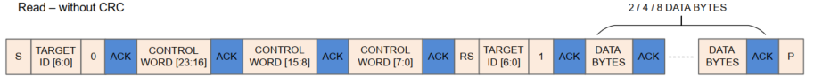

**HAL_I2C_Master_Transmit()**

**HAL_I2C_Master_Receive()**

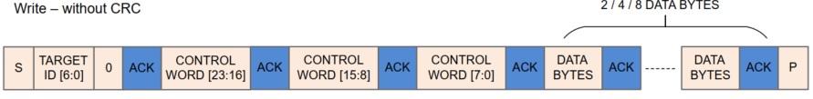

**HAL_I2C_Master_Transmit()**